**Architecture Diagram:**

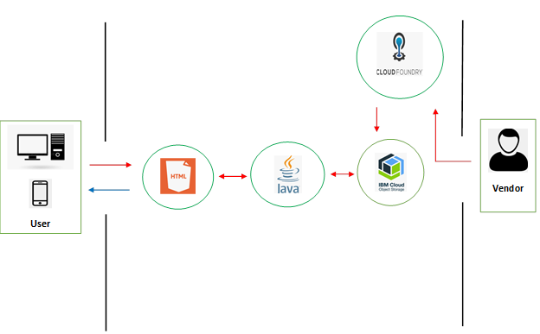

1. The user navigates to the site/mobile app.
2. The UI is HTML with use of CSS and JS and is very user friendly.
3. IBM Cloud foundry app is used to supply images to the API
4. IBM Cloud object storage is used to store the images received from the vendor

**Future Scope:**

* We currently unable to use triggers due to limitations of IBM Cloud Lite. We would use triggers so it can trigger conversion of video to image as soon as the video hits the bucket.
* Watson visual recognition for identifying the images from videos.
* Chatbots to answer queries of the user.
* Notification service on stock updates.
* We can provide the geo location of the vendors listed in our application for ease of access.

**Sustainability plan:** The application is currently designed for Vegetables and Fruits, but it can be expanded to cover various other commodities from essentials to medical supplies. Social distancing is recommended to be continued at least up to 2022 if not further. This application would help curb overcrowding and would always be in demand.

**Funding needs:** Premium IBM cloud account. The web footage can be the webcam footage itself hence reducing any extra effort to obtain the regular video feed.

**Business from the product:** Single stop solution for suppliers, vendors and customers. Vendors can be charged for slot on the application to display their stock.